**Texture Descriptors for an Improved Automatic Breast Tumor Segmentation in Ultrasound Images**

**Fabian Torres, Zian Fanti, Ping-Lang Yen, F. Arambula Cosio.**

**Abstract**

Texture descriptors have been widely used to improve the results of automatic breast tumor segmentations in ultrasound images. In this work we present a comprehensive evaluation of the ability of different types of texture descriptors to enhance the contrast between breast tumors and healthy tissue in ultrasound images and how they affect the results of automatic tumor segmentation. We evaluated descriptors extracted from the analysis of the histogram, co-occurrence and run-length matrices. The contrast between the tumor region and normal breast tissue was evaluated using the signal to noise ratio (SNR), contrast to noise ratio (CNR), histogram intersection and Minkowski-form Distance, between the tumor region and normal tissue histograms. We have implemented a probabilistic segmentation method in order to evaluate the changes in the accuracy, sensitivity, specificity, positive predictive value (PPV) and negative predicted value (NPV) of the method when using different texture descriptors. The Short Run Emphasis of the run-length matrix showed better results with values of 91.02%, 88.58%, 96.89%, 96.34% and 89.16% respectively. The mean of the histogram as a texture descriptor also showed good automatic segmentation results and has the advantage of low computational cost compared with the run-length and co-occurrence texture descriptors.

**Keywords:** ultrasound, texture analysis, breast tumor segmentation, image contrast enhancement

**Introduction**

Since breast cancer has become the number one cause of death among women around the world, it is very important to have fast and accurate diagnostic methods to improve the prognosis of the patient1. Although biopsy is the gold standard for cancer diagnosis, minimal invasion methods for diagnosis are preferred in order to reduce further complications. Mammography and ultrasound are the two main medical imaging modalities for breast tumor screening, several diagnostic methods using ultrasound images have been proposed. Currently ultrasound is responsible for about one in five of all diagnostic images2, the expert ultrasonographer estimates the malignity of a tumor mainly from its shape and echogenicity (which is an indication of the tumor density).

The visualization of lesions in ultrasound breast images is a difficult task due to some intrinsic characteristics of the images like speckle, acoustic shadows and blurry edges3. In this work we report a comprehensive analysis of textural features which improve the outcome of automatic breast tumor segmentation in ultrasound images. Accurate automatic segmentation of breast tumors can help the experts to achieve faster diagnoses, and it’s a key stage of fully automatic systems for breast cancer diagnosis using ultrasound images.

Texture analysis refers to the characterization of regions in an image by their texture content, quantifying intuitive qualities described as roughness, smoothness, silkiness and bumpiness4. In ultrasound images echo patterns are generally referred to as textures5; a good breast tumor segmentation method in ultrasound images should take into account texture features in order to differentiate tumors from other objects with similar gray intensities, like glands and acoustic shadows6, however texture analysis in ultrasound images is not an easy task and many texture metrics have been used to model the echo patterns in breast tumors. Several automatic and semi-automatic segmentation methods using pixel intensity along with texture information have been proposed6. Some of these methods use first-order texture descriptors obtained from histogram statistics6,7, but these descriptors are not able to give a good texture description in ultrasound images because they do not take into account the spatial relation between pixels and gray-levels8; because of this, other proposed methods use second-order texture descriptors extracted from co-occurrence matrices statistics9, but the computational cost for computing the co-occurrence matrix is very high and much more demanding while working in per-pixel computation10. Other texture descriptors extracted from run-length matrices statistics have been used for breast tumor classification in ultrasound images.

Texture is a rich source of visual information and there are a number of methods for texture representation, because of this, it is difficult to define the properties that can be used to effectively distinguish textures found in a given image11. For this reason, it is important to evaluate which texture descriptor is the one that improves the outcome of a segmentation method. In this work we report an extensive evaluation of how texture descriptors extracted from histogram statistics, co-occurrence matrices statistics and run-length matrices statistics modify the contrast between the tumor region and the surrounding tissue in breast ultrasound images and how this affects the results of an automatic segmentation algorithm, in order to find which are the best texture descriptors to effectively distinguish between normal tissue and tumors in breast ultrasound images. Except for the work done by Liao et al5, where they compare the ability of different texture descriptors extracted from co-occurrence matrices statistics to enhance the contrast between the tumor region and the surrounded tissue and how it affects the results of manual and automatic segmentations, there is no related work that evaluates the ability of different texture descriptors, extracted from first and second order statistics, to improve the automatic segmentation of tumors in breast ultrasound images. To evaluate the ability of these descriptors to enhance the contrast between the tumor region and the healthy tissue, we obtained a texture image using per-pixel computation using different texture descriptors and compare the signal to noise ratio (SNR), contrast to noise ratio (CNR), histogram intersection and Minkowski-form Distance between the tumor region and healthy tissue histograms in each image. We have also evaluated the ability of these descriptors to improve the segmentation results; we implemented a probabilistic segmentation method based on the work of Madabushi et al6 and compared the accuracy, sensitivity, specificity, positive predictive value (PPV) and negative predicted value (NPV) of the method when using different texture descriptors.

Porque evaluamos contraste?

**Texture Analysis**

Here we evaluate texture descriptors extracted from histogram statistics, co-occurrence matrices statistics and run-length matrices statistics.

First-order texture descriptors are extracted from the original image values; they do not consider the spatial relationships with neighborhood pixels12. The most frequently used first-order texture descriptors are central moments of the histogram13. These descriptors have been used for the segmentation and classification of breast tumors in ultrasound images; Huang et al7 use the Mean and Entropy of the histogram to characterize the texture of breast tumors, also the Kurtosis and Skewness of the histogram have been used for tumor classification by Pilouras et al14. Another first order texture descriptor, extracted from the image original intensity values, used for automatic breast tumor segmentation in ultrasound images is the difference of the intensity of each pixel with the mean of its neighborhood6.

The gray-level co-occurrence matrix describes how frequently two gray-levels appear in a window separated by a given distance and a given angle13. Second-order texture descriptors computed from the analysis of the co-occurrence matrices have been proposed by Haralick15*.* Some of these texture descriptors have been used for the segmentation and classification of breast tumors; Liu et al9 use the entropy and contrast of the co-occurrence matrix for breast tumor segmentation. Liao et al5 evaluate the ability of the homogeneity, contrast, energy and variance of the co-occurrence matrix to enhance the contrast of tumors in breast ultrasound images, concluding that the variance of the co-occurrence matrix is the best texture descriptor of the four to be used in breast tumor contrast enhancement in ultrasound images. Although these descriptors take into account the spatial relationship between pixels the computational cost of computing the co-occurrence matrix is very high compared to first order descriptors10.

Another method to characterize texture that also takes into account the spatial relationship between pixels is based on run lengths of image gray-levels, where the run-length matrix of an image is defined as the number of runs with pixels of equal gray level and a given run-length12; although these descriptors have not been widely used as an effective texture classification and analysis method, it has been demonstrated by Tang et al16 that there is rich texture information contained in this matrices. Galloway17 proposed five texture descriptors based on the analysis of run-length matrices: short run emphasis (SRE), long run emphasis (LRE), gray-level nonuniformity (GLN), run-length nonuniformity (RLN) and run percentage (RP); these descriptors have been successfully used for the classification of breast tumors in ultrasound images14,18,19. A list of the texture descriptors evaluated in this work, extracted from histogram, co-occurrence and run-length statistics is shown in table 1

Table 1. List of evaluated texture descriptors.

|  |  |  |
| --- | --- | --- |
| First order | Mean  Entropy  Kurtosis  Skewness  Mean Difference | Huang et al7  Huang et al7  Pilouras et al14  Pilouras et al14  Madabhushi et al6 |
| Co-occurrence | Entropy  Contrast  Homogeneity  Energy  Variance | Liu et al9  Liu et al 9  Liao et al5  Liao et al 5  Liao et al 5 |
| Run-length | Short Run Emphasis  Long Run Emphasis  Gray-Level Nonuniformity  Run-length Nonuniformity | Lefebvre et al19  Lefebvre et al 19  Murmis et al18  Murmis et al 18 |

**Segmentation Method**

Because of inherent artifacts in breast ultrasound images such as speckle and blurry edges, the segmentation of tumors is not an easy task3. Several works have been done in order to create semi-automatic and automatic methods. Based on the literature, these methods can be divided in two groups; thresholding based methods and classifiers based methods. The thresholding based methods have low computational cost and usually use only gray-level intensities of the pixels to segment de image3,7,20. The classifier based methods are more robust since they use more than one feature for classification, but the implementation and the computational cost increments considerably compared with thresholding based methods1,6,9,21; the image features used for classifier based methods should be appropriately selected according to the application, texture information might be suitable for ultrasound images3.

We have implemented an automatic segmentation method based on the work of Madabhushi et al6. This method is based on a region-growing algorithm applied to a probability image instead of an intensity image. The probability image is constructed with the probabilities of each pixel of belonging to the tumor region, based on the pixel intensity and texture features. Two density probability functions (*pdf*) are constructed using the gray-level intensity and texture features from previously segmented tumors; the joint probability of the two *pdfs* is computed as the pixel probability to belong to a tumor.

Most of the proposed methods for tumor segmentation in breast ultrasound images use a pre-processing step to obtain more homogenous regions and enhance the contrast between the tumor and the surrounding tissue. For contrast enhancement some works used the sticks method3,20,21, but Madabushi et al6 proposed the use of histogram equalization because it is a fast method with good results in tumor enhancement. To obtain more homogenous regions a Gaussian filter was used by Chen et al3 and a Butterworth filter was used by Madabhushi et al6, but Abd et al22 showed that the Gaussian Anisotropic Filter has better results in ultrasound images since it preserves boundaries. Based on this, we implemented a pre-processing step to obtain a contrast enhanced intensity image using histogram equalization and then a Gaussian Anisotropic Filter to obtain more homogenous regions while preserving the edges.

To obtain a texture image using the texture descriptors listed in table 1 we use per pixel computation, with the parameters proposed in the different cited works. Because texture parameters in ultrasound images characterize the acoustic properties of the tissue19, the texture image was computed from the original image without any pre-processing step to avoid elimination of any texture related information.

After computing the probability image, using the pre-processed intensity and texture joint probability as explained before, the method uses a region growing algorithm on the probability image to obtain the region that belongs to the tumor. To include one pixel $t$ inside the tumor region $T$ it should satisfy two conditions: First, the probability of the pixel of belonging to the tumor $I_{p}\left(t\right)$ should be inside a range of values between the mean of the tumor region probability $J_{C_{0}}$ by upper and lower thresholds $β_{1 }, β_{2}$; second, at least one more pixel in the immediate neighborhood of the pixel $N_{t}\left(t\right)$ should intersect with the tumor region $T$; these conditions are shown in equation 1. The seed point of the region is automatically determined by the method using the probability of each pixel, along with spatial information about the potential seed; you can find the complete description of the method in the article published by Madabhushi et al6.

|  |  |
| --- | --- |
|  | (1) |

**where:**

**Experiment and Results**

A data base of 30 breast ultrasound images with a lesion were acquired with a GE Healthcare Voluson 73 in the Changhua Christian Hospital. The images have a size of 181x163 pixels. After manual localization of the breast tumor and the selection of the region of interest the images were processed in the open source software itk-SNAP for image enhancement and semi-automatic segmentation supervised by an expert sonographer.

**Contrast enhancement using texture descriptors**

Evaluation of contrast enhancement can be done with different indices, there is no standardized solution for this; therefore, it is important to compute several indices for this purpose, in order to have a good contrast enhancement evaluation23. To evaluate the ability of the texture descriptors listed in table 1 to enhance the contrast between the tumor region and the surrounding tissue we used the signal to noise ratio (SNR) and the contrast to noise ratio (CNR) both used by Liao et al5.

|  |  |
| --- | --- |
|  | (2) |
|  | (3) |

where $μ_{ROI}$ and $μ_{Background}$ are mean brightness values of the tumor region (ROI) and the tissue (Background) respectively, and $σ_{ROI}$ and $σ_{Background}$ are the standard deviation of the ROI and the background respectively.

In addition to the SNR and CNR we computed the Minkowski-form distance (MD) and the histogram intersection (INT) between the ROI and background regions as similarity measurements between histograms. The Minkowsky distance is often used for computing dissimilarities between histograms24. The intersection of the histograms is a useful similarity measurement between two histograms when the number of pixels between regions is different, it is well suited to deal with scale changes25.

|  |  |
| --- | --- |
|  | (4) |
|  | (5) |

where $H_{ROI}$ and $H_{Background}$ are the normalized histograms of the ROI and the background.

Along with contrast enhancement, another important aspect to take into account when using texture analysis for image segmentation is the ability of the descriptor to preserve the edges of the structures we want to segment5. To evaluate this, we used the edge preservation index (EPI) defined as

|  |  |
| --- | --- |
|  | (6) |

where $p_{T}(i,j)$ is the value of the texture image pixel and $p_{o}(i,j)$ is the value of the original image; $p_{T}(i,j)$ and $p_{o}(i,j)$ are in the edge area, previously segmented in the original image26.

We compare the SNR, CNR, MD, INT and EPI of the original images with the texture images obtained using per-pixel computation with the descriptors listed in table 1. Table 2 shows the results of MD, INT, SNR, CNR and EPI for the original image, while table 3 shows which texture descriptors improve each contrast index. The results for the pre-processing stage used in the segmentation algorithm to obtain an intensity image with a higher contrast are also shown in table 3.

The first order descriptor that obtained better results enhancing the image was the Mean of the histogram with higher values of MD, INT and CNR than the original image, however the SNR was lower than in the original image and the ability to preserve borders was low; the SNR and the EPI were improved by the Entropy and Mean Difference descriptors respectively, however the other contrast enhancement indices had no good results using these descriptors.

The results also show that using second order descriptors based on the co-occurrence matrix for image enhancement are not useful since none of the texture descriptors proposed by Haralick15 are able to enhance the contrast of the image. Although none of these descriptors improve the contrast of the image, the Homogeneity of the co-occurrence matrix had higher values in all indices than the other co-occurrence based descriptors. Except for the Variance and Energy, all the Haralick texture descriptors improved the SNR significantly but the MD, INT, CNR and EPI were reduced considerably using these descriptors. Looking at equation 2 a higher SNR value may imply two things, the mean gray-level of the region increased and/or the standard deviation of the region decreased, making the region brighter and/or more homogenous, but if the contrast between the region and the background is diminished the visualization of the region of interest is going to be more difficult, since the mean gray-level and the homogeneity of the regions is very similar. In figure 1 is shown how a breast tumor with high SNR in an ultrasound image does not imply a better visualization of the lesion, the original image has a SNR value of 1.4940 and a CNR value of 1.4882 and the texture image, obtained using the correlation of the co-occurrence matrix as texture descriptor, has a SNR value of 3.2322 and a CNR value of 0.0744.

Table 3 shows that of all the Run-length texture descriptors the SRE of the run-length matrix have better results improving the MD, INT, SNR and CNR of the image; this texture feature is also the one that enhances the Minkowski-form distance and the histogram intersection the most, making easier the differentiation between regions using their probabilities, since the normalized histogram can be used as the probability density function of each gray-level to belong to a region27. As the Haralick texture descriptors, none of the run length texture descriptors was able to preserve borders, decreasing the EPI significantly; in fact, of all the texture descriptors listed in table 1, the only one able to preserve edges was the difference of the mean6

Table 2. Original image contrast indices

|  |  |  |  |  |
| --- | --- | --- | --- | --- |
| MD | INT | SNR | CNR | EPI |
| 1.4136 ±0.3264 | 0.2932 ±0.1632 | 1.7450 ±0.5285 | 1.0784 ±0.3316 | 1 ±0 |

Table 3. Texture descriptors than enhance the contrast

|  |  |  |  |  |
| --- | --- | --- | --- | --- |
| Index | Type | | Descriptor | Value |
| MD | Texture | Histogram | Mean | 1.5460 ±0.3075 |
| Haralick | -- | -- |
| Run-length | LRE  SRE | 1.4811 ±0.3119  1.6217 ±0.2944 |
| Intensity | | Filter  Filter + Equalization | 1.4953 ±0.3132  1.5383 ±0.3067 |
| INT | Texture | Histogram | Mean | 0.2270 ±0.1537 |
| Haralick | -- | -- |
| Run-length | LRE  SRE | 0.2594 ±0.1559  0.1892 ±0.1472 |
| Intensity | | Filter  Filter + Equalization | 0.2524 ±0.1566  0.2308 ±0.1534 |
| SNR | Texture | Histogram | Entropy  Kurtosis  Skewness  Std | 3.3629 ±1.0537  1.9337 ±0.5872  2.4845 ±0.7100  2.1388 ±0.5796 |
| Haralick | Contrast  Correlation  Homogeneity  Variance | 1.8608 ±0.5232  3.6850 ±0.9207  4.0034 ±0.9603  1.7103 ±0.3714 |
| Run-length | GLN  RLN  SRE | 2.6275 ±0.8319  2.2124 ±0.4260  3.3263 ±1.0729 |
| Intensity | | -- | -- |
| CNR | Texture | Histogram | Mean | 1.2495 ±0.3713 |
| Haralick | -- | -- |
| Run-length | SRE | 1.2144 ±0.3924 |
| Intensity | | Filter  Equalization  Filter + Equalization | 1.1682 ±0.3610  1.1105 ±0.3408  1.1682 ±0.3610 |
| EPI | Texture | Histogram | Difference | 1.6522 ±0.2802 |
| Haralick | -- | -- |
| Run-length | -- | -- |
| Intensity | | Equalization  Filter + Equalization | 1.7296 ±0.2863  1.4429 ±0.3702 |

Figure 2 shows a breast tumor ultrasound image, the pre-processed intensity image and texture images obtained by per-pixel computation using the Mean of the histogram, the Homogeneity of the co-occurrence matrix and SRE of the run-length matrix texture descriptors, while figure 3 shows the normalized histograms of the background (red) and the tumor region (blue) of each image in figure 2.

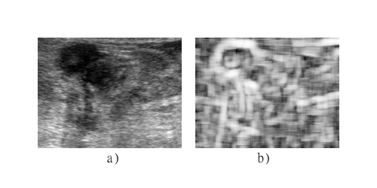

Figure 1. Comparison of lesion visualization with different SNR values a) original image and b) texture image obtained with the correlation of the co-occurrence matrix.

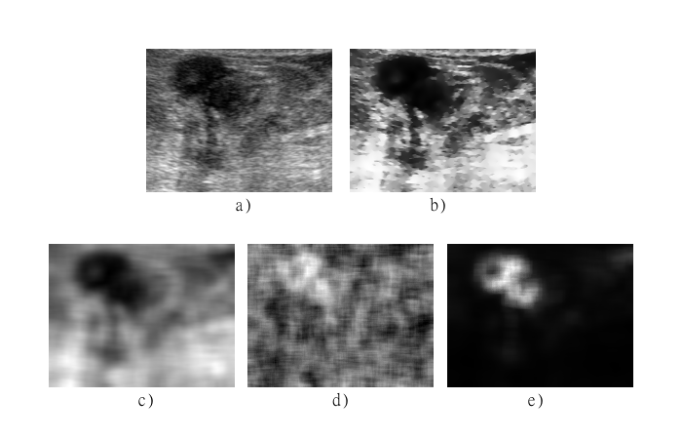

Figure 2. Textural analysis of breast ultrasound images. a) original ultrasound image, b) pre-processed intensity image, c) mean of the histogram texture image, d) Homogeneity of the co-occurrence matrix texture image, and e) SRE of the run-length matrix texture image.

**Segmentation evaluation**

We used the segmentation method reported by Madabhushi et al6 which includes a pre-processing step to obtain an intensity image, and a texture image in order to build a probability image to segment the tumor with a region growing algorithm. The intensity image is obtained by enhancing the contrast with histogram equalization and homogenizing regions while preserving edges with a Gaussian anisotropic filter. Different texture images were obtained using the texture descriptors listed in table 1. Here we evaluate the results of the segmentation method when using different texture descriptors and compare them with the results without using any texture information (using only the normalized histogram of the intensity image as probability function). To evaluate the segmentation results we used the accuracy, sensitivity, specificity, positive predictive value (PPV) and the negative predictive value NPV9:

|  |  |
| --- | --- |
|  | (7) |
|  | (8) |
|  | (9) |
|  | (10) |
|  | (11) |

where $TP, TN, FP$ and $FN$ are the true positive, true negative, false positive and false negative pixels found in the segmentation process. These indices were evaluated for the 30 images using leave-one-out cross-validation. The accuracy is the ratio of correctly classified pixels (true positives and true negatives) in the entire area of the image28. The sensitivity and specificity are often used to complement the evaluation of segmentation algorithms, sensitivity is used for measuring how many pixels in the region of interest are correctly segmented, it does not tell anything about how many pixels in the background would be segmented as tumors29; the specificity measures how many pixels in the background are correctly excluded and does not tell if a tumor pixel would not be correctly segmented30. The positive and negative predictive values are related with the sensitivity, specificity and the size of the tumor region, the predictive values will change between images if the tumor region covers a different percentage of the whole image, it is important to take this into account since breast tumors size change between patients31. Table 4 shows the segmentation results using only the original image without any pre-processing (top row) and using the intensity image obtained with histogram equalization and a Gaussian anisotropic filter (bottom row). The pre-processing step was able to improve the segmentation results, making the accuracy, specificity and PPV significantly higher, while the sensitivity and NPV were diminished by 1.24% and 0.54% respectively.

Table 4. Original and Intensity images segmentation results

|  |  |  |  |  |  |
| --- | --- | --- | --- | --- | --- |
| Image | Accuracy | Sensitivity | Specificity | PPV | NPV |
| Original | 83.89% | 86.51% | 86.63% | 78.94% | 88.84% |
| Intensity | 87.13% | 85.26% | 90.52% | 85.96% | 88.30% |

We also evaluated the ability of the different texture descriptors listed in table 1 to enhance the segmentation results. Almost all of the first order texture descriptors enhanced the segmentation results except for the NPV, which was not improved by any of the texture descriptors. The first order texture descriptor that leads to better segmentation results was the mean of the histogram, having higher percentage of accuracy, sensitivity, PPV and NPV, with values of 90.58%, 89.36%, 94.08% and 87.08% respectively; the higher value of specificity was obtained using the entropy of the histogram, but the difference between the specificity of the mean and the entropy is only of 0.36% making it insignificant; the NPV was diminished by 1.22% using the mean of the histogram. The accuracy, sensitivity and NPV of the segmentations obtained using the Haralick texture descriptors where similar to the ones using the first order descriptors; the higher values of accuracy (90.60%), sensitivity (88.66%) and NPV (87.24%) were obtained with the homogeneity of the co-occurrence matrix; although this texture descriptor also improves significantly the specificity (94.84%) and PPV (93.40%) of the segmentation, the contrast of the co-occurrence matrix lead to higher values in these indices, getting values of 96.71% and 96.16% respectively; none of the Haralick texture descriptors was able to increase the NPV value. Using run-length texture descriptors in the segmentation lead to better results in all indices, except for the sensitivity where the mean of the histogram obtained the higher value; the LRE and the SRE were the only texture descriptors of the ones listed in table 1 able to increase the NPV value, having the highest value (89.16%) using the SRE of the run-length matrix; the highest values of accuracy, specificity and PPV were also obtained using the SRE of the run-length matrix, while the highest value of sensitivity was obtained with the GLN texture descriptor.

Table 5 shows that using the listed texture descriptors along with the pre-processed image the accuracy, specificity and the PPV can be significantly improved, and although, the increase of sensitivity and NPV in the segmentation using texture descriptors is not as significant as in the accuracy, specificity and PPV, table 5 shows that the segmentation results are better than using only the original image or the pre-processed intensity image, compared with the results shown in table 4. reescribir While none of the first order and Haralick texture descriptors were able to increase the NPV value of the segmentation, table 5 shows that the SRE was able to increase it by only 0.32%; although this increment is insignificant, at least this descriptor do not diminish the NPV of the segmentation.

Table 5. Original and Intensity images segmentation results

|  |  |  |  |  |  |  |
| --- | --- | --- | --- | --- | --- | --- |
| Category | Descriptor | Accuracy | Sensitivity | Specificity | PPV | NPV |
| First Order | Mean | 90.58% | 89.36% | 95.24% | 94.08% | 87.08% |
| Haralick | Homogeneity | 90.60% | 88.66% | 94.84% | 93.40% | 87.24% |
| Run-length | SRE | 91.02% | 88.58% | 96.89% | 96.34% | 89.16% |

Figure 4 shows the segmentation of a breast tumor in an ultrasound image using different texture descriptors along with the pre-processed intensity image with the probabilistic segmentation method implemented here, it also shows the segmentation results obtained when using only the original intensities of the image and the pre-processed intensity image without any texture information. Table 6 shows the accuracy, sensitivity, specificity, PPV and NPV of the segmented images shown in figure 4.

It can be seen in table 6 that using texture descriptors along with a pre-processed intensity image for breast tumor segmentation in the ultrasound image shown in figure 1a) can upgrade the results considerably. Although the sensitivity and NPV are diminished using the texture descriptors, the difference is insignificant (1% and .3% respectively) comparing it with the increase in accuracy, specificity and PPV values (16%, 24% and 34% respectively) using the SRE of the run-length matrix as texture descriptor.

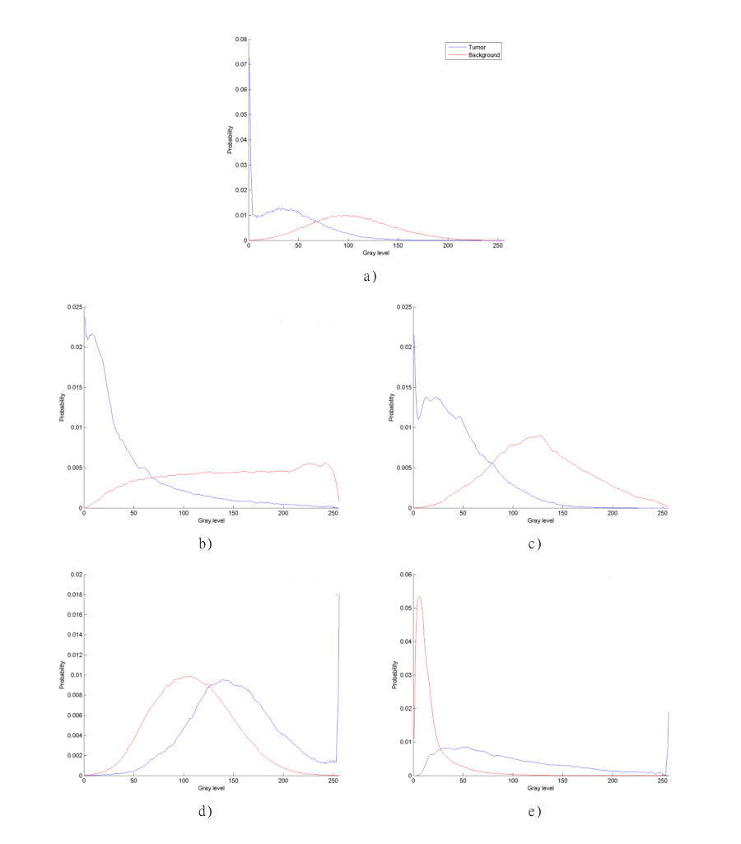

Figure 3. Normalized histograms of textural analysis. a) original ultrasound image, b) pre-processed intensity image, c) mean of the histogram texture image, d) Homogeneity of the co-occurrence matrix texture image, and d) SRE of the run-length matrix texture image.

Table 6. Segmentation results for the segmented images shown in figure 4

|  |  |  |  |  |  |
| --- | --- | --- | --- | --- | --- |
| Descriptor | Accuracy | Sensitivity | Specificity | PPV | NPV |
| Original | 82.41% | 99.75% | 74.03% | 64.98% | 99.03% |
| Intensity | 91.10% | 99.49% | 85.14% | 82.62% | 99.57% |
| Mean | 97.96% | 98.50% | 97.42% | 97.39% | 98.52% |
| Homogeneity | 95.97% | 98.92% | 93.96% | 92.96% | 98.98% |
| LRE | 98.28% | 98.74% | 98.84% | 98.85% | 98.72% |

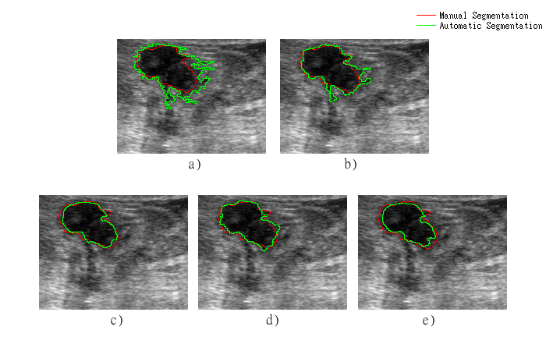

Figure 4. Segmentation of a breast tumor using a) original image, b) pre-processed intensity image c) mean of the histogram, c) homogeneity of the co-occurrence matrix, and d) LRE of the run-length matrix.

**Discussion and Conclusion**

Texture descriptors have been widely used in breast ultrasound images for tumor segmentation, since they help to differentiate structures with similar gray-level intensities as tumors, like acoustic shadows6. In this work we reported a quantitative evaluation of different texture descriptors in order to find out which one is the most effective to enhance the contrast of the image and which one leads to better segmentation results.

Image quality is a key aspect to consider in ultrasound images since they are affected by many types of artifacts, making it hard for an observer to interpret the images and obtain quantitative and qualitative information from them32. Because of the noisy nature of the ultrasound images and the low contrast between breast cancer and surrounding tissue, it is difficult to provide an accurate and effective diagnosis33. The ability of different texture descriptors to enhance the contrast between the tumor region and normal tissue was evaluated with five indices (MD, INT, SNR, CNR and EPI). It was shown in the results that some of the texture descriptors listed in table 1 are able to increase one or more of the used contrast indices, and that SRE of the run-length matrix was able to increase all the indices but not the EPI; in fact none of the used texture descriptors, except for the difference of the histogram, was able to preserve edges; this may be a drawback when dealing with boundary detection. It was also shown that the co-occurrence based texture descriptors proposed by Haralick15 are no good for image enhancement since none of them was able to increase the value of the contrast indices, except for the SNR but this may not lead to a better visualization of the tumor region as can be seen in figure 1. The mean of the histogram also showed good results enhancing the contrast of the image, enhancing almost all of the contrast indices except for the SNR and EPI; this texture descriptor may be used instead of the SRE of the run-length matrix for image enhancement when time is an important factor since first order texture descriptors have lower computational cost than higher order descriptors14. The proposed pre-processing intensity step, using histogram equalization and Gaussian anisotropic filtering, showed similar results to the mean of the histogram, but this pre-processing step was able to preserve the edges of the tumor, meaning that it is a good alternative for breast tumor contrast enhancement in ultrasound images.

mejorar redaccion enhance the segmentation results of a probabilistic segmentation method like the one implemented here, indicating that texture features provide useful information that helps to distinguish between tumors and normal tissue in breast ultrasound images. The segmentation was evaluated using five indices (accuracy, sensitivity, specificity, PPV and NPV), and we use a semi-automatic segmentation supervised by a physician as the ground truth. Table 5 shows that SRE of the run-length matrix is the texture descriptor, of all listed in table 1, that enhance the segmentation results the best, having a significant increase in all of the indices used here to evaluate the segmentation, except for the NPV where the increase was not significant but the value was not diminished; it is important to notice that this texture descriptor is also the one that shows better results in contrast enhancement increasing the MD and decreasing the histogram intersection significantly making easier to differentiate between regions when using the normalized histogram as a probability function.

Our results show that run-length texture descriptors lead to the best contrast enhancement and segmentation results. Texture analysis depends on the parameters used to obtain the texture feature, such as window size, distance and angle in the case of co-occurrence based descriptors, and run-length distance when using run-length texture features; the parameters used here were the same used in the cited works. In this work the segmentation was made using only one texture feature, in order to evaluate its effects accurately.

**Acknowledge:** The authors would like to thank the National Council of Science and Technology and the National Autonomous University of Mexico for the support of this work.

**References**

1. Jiao J, Wang Y. Automatic boundary detection in breast ultrasound images based on improved pulse coupled neural network and active contour model. 5th International Conference on Bioinformatics and Biomedical Engineering, iCBBE 2011 [Internet]. 2011. Available from: http://www.scopus.com/inward/record.url?eid=2-s2.0-79960133488&partnerID=40&md5=2fbc2be3a6c29e8afa2686a80a22de7d

2. Halliwell M. A tutorial on ultrasonic physics and imaging techniques. Proc Inst Mech Eng Part H J Eng Med [Internet]. 2010;224(2):127–42. Available from: http://www.scopus.com/inward/record.url?eid=2-s2.0-76849088916&partnerID=40&md5=2e31c49ee5eacb38e9d8eff368395571

3. Chen D-R, Chang R-F, Wu W-J, Moon WK, Wu W-L. 3-D breast ultrasound segmentation using active contour model. Ultrasound Med Biol [Internet]. 2003;29(7):1017–26. Available from: http://www.scopus.com/inward/record.url?eid=2-s2.0-0038104383&partnerID=40&md5=7ce9fd930964c1fa833d59c54cbee0f2

4. Rajaei A, Dallalzadeh E, Rangarajan L. Segmentation of Pre-processed Medical Images: An Approach Based on Range Filter. Int J Image, Graph Signal Process [Internet]. 2012 Sep 1 [cited 2015 Feb 12];4(9):8. Available from: http://www.mecs-press.org/ijigsp/ijigsp-v4-n9/v4n9-2.html

5. Liao YY, Wu JC, Li CH, Yeh CK. Texture feature analysis for breast ultrasound image enhancement. Ultrason Imaging. 2011;33:264–78.

6. Madabhushi A, Metaxas DN. Combining low-, high-level and empirical domain knowledge for automated segmentation of ultrasonic breast lesions. IEEE Trans Med Imaging [Internet]. 2003;22(2):155–69. Available from: http://www.scopus.com/inward/record.url?eid=2-s2.0-0038398643&partnerID=40&md5=8f3c0cb69868bd81039a7d66c017a20e

7. Huang S-F, Chen Y-C, Woo KM. Neural network analysis applied to tumor segmentation on 3D breast ultrasound images. 2008 5th IEEE International Symposium on Biomedical Imaging: From Nano to Macro, Proceedings, ISBI [Internet]. 2008. p. 1303–6. Available from: http://www.scopus.com/inward/record.url?eid=2-s2.0-51049090141&partnerID=40&md5=fb1a47c542dd589d7e2fb66be1f4d161

8. Bader W, Böhmer S, Van Leeuwen P, Hackmann J, Westhof G, Hatzmann W. Does texture analysis improve breast ultrasound precision? Ultrasound Obstet Gynecol [Internet]. 2000;15(4):311–6. Available from: http://www.scopus.com/inward/record.url?eid=2-s2.0-0034543860&partnerID=40&md5=de959bbf56615fddc3548fa4861e418e

9. Liu B, Cheng HD, Huang J, Tian J, Tang X, Liu J. Fully automatic and segmentation-robust classification of breast tumors based on local texture analysis of ultrasound images. Pattern Recognit [Internet]. 2010;43(1):280–98. Available from: http://www.scopus.com/inward/record.url?eid=2-s2.0-68949159836&partnerID=40&md5=849f4e2d8f796deb81ef01d7be063f00

10. F. Igual R. Mayo THUCAR, M.Ujaldon. Optimizing Co-Occurrence Matrices on Graphics Processors Using Sparse Representations. 9th Int� Workshop on State-of-the-Art in Science and Parallel Computing, Trondheim, Norway. 2008.

11. Yassine IS, Belfkih S, Najah S, Zenkouar H. A new method for texture image segmentation. 2010 5th International Symposium On I/V Communications and Mobile Network [Internet]. IEEE; 2010 [cited 2015 Feb 12]. p. 1–4. Available from: http://ieeexplore.ieee.org/lpdocs/epic03/wrapper.htm?arnumber=5656161

12. Selvarajah S, Kodituwakku SR. Analysis and Comparison of Texture Features for Content Based Image Retrieval. Int J Latest Trends Comput [Internet]. 2011;2(1):108–13. Available from: http://www.ijltc.excelingtech.co.uk/vol2issue1/18-vol2issue1.pdf

13. Aggarwal N, Agrawal RK. First and Second Order Statistics Features for Classification of Magnetic Resonance Brain Images. J Signal Inf Process. 2012;3(May):146–53.

14. Piliouras N, Kalatzis I, Dimitropoulos N, Cavouras D. Development of the cubic least squares mapping linear-kernel support vector machine classifier for improving the characterization of breast lesions on ultrasound. Comput Med Imaging Graph [Internet]. 2004;28(5):247–55. Available from: http://www.sciencedirect.com/science/article/pii/S0895611104000515

15. Haralick RM. Statistical and structural approaches to texture. Proc IEEE. 1979;67(5):786–804.

16. Tang X. Texture information in run-length matrices. Image Process IEEE Trans. 1998;7(11):1602–9.

17. Galloway MM. Texture analysis using gray level run lengths. Comput Graph Image Process [Internet]. 1975;4(2):172–9. Available from: http://www.sciencedirect.com/science/article/pii/S0146664X75800086

18. Murmis VG, Gisvold JJ, Kinter TM, Greenleaf JF. Texture analysis of ultrasound B-scans to aid diagnosis of cancerous lesions in the breast. Ultrasonics Symposium, 1988 Proceedings, IEEE 1988. 1988. p. 839–42 vol.2.

19. Lefebvre F, Meunier M, Thibault F, Laugier P, Berger G. Computerized ultrasound B-scan characterization of breast nodules. Ultrasound Med Biol [Internet]. 2000;26(9):1421–8. Available from: http://www.sciencedirect.com/science/article/pii/S0301562900003021

20. Chang R-F, Wu W-J, Moon WK, Chen D-R. Automatic ultrasound segmentation and morphology based diagnosis of solid breast tumors. Breast Cancer Res Treat [Internet]. 2005;89(2):179–85. Available from: http://www.scopus.com/inward/record.url?eid=2-s2.0-13844267711&partnerID=40&md5=e041bd7389900373ab3295633ebbfbba

21. Huang Q-H, Lee S-Y, Liu L-Z, Lu M-H, Jin L-W, Li A-H. A robust graph-based segmentation method for breast tumors in ultrasound images. Ultrasonics [Internet]. 2012;52(2):266–75. Available from: http://www.scopus.com/inward/record.url?eid=2-s2.0-81855206603&partnerID=40&md5=64f63b465f4e88b93568bd6afd633289

22. Abd-Elmoniem KZ, Youssef A-BM, Kadah YM. Real-time speckle reduction and coherence enhancement in ultrasound imaging via nonlinear anisotropic diffusion. IEEE Trans Biomed Eng [Internet]. 2002;49(9):997–1014. Available from: http://www.scopus.com/inward/record.url?eid=2-s2.0-0036721081&partnerID=40&md5=d5f5fbf546ad5e4399367f427a718bd0

23. Huang D-S, McGinnity M, Heutte L, Zhang X-P, editors. Advanced Intelligent Computing Theories and Applications [Internet]. Berlin, Heidelberg: Springer Berlin Heidelberg; 2010 [cited 2015 Mar 2]. Available from: http://www.springerlink.com/index/10.1007/978-3-642-14831-6

24. Rubner Y, Tomasi C, Guibas LJ. The Earth Mover’s Distance as a Metric for Image Retrieval. Int J Comput Vis [Internet]. Kluwer Academic Publishers; [cited 2015 Feb 24];40(2):99–121. Available from: http://link.springer.com/article/10.1023/A%3A1026543900054

25. Barla A, Odone F, Verri A. Histogram intersection kernel for image classification. Proceedings 2003 International Conference on Image Processing (Cat No03CH37429) [Internet]. IEEE; [cited 2015 Feb 24]. p. III – 513–6. Available from: http://ieeexplore.ieee.org/articleDetails.jsp?arnumber=1247294

26. Han Chumning, Guo Huadong, Wang Changlin. Edge preservation evaluation of digital speckle filters. IEEE International Geoscience and Remote Sensing Symposium [Internet]. IEEE; 2002 [cited 2015 Feb 26]. p. 2471–3. Available from: http://ieeexplore.ieee.org/lpdocs/epic03/wrapper.htm?arnumber=1026581

27. Legg PA, Rosin PL, Marshall D, Morgan JE. Improving accuracy and efficiency of mutual information for multi-modal retinal image registration using adaptive probability density estimation. Comput Med Imaging Graph [Internet]. 2013 Jan [cited 2015 Apr 22];37(7-8):597–606. Available from: http://www.sciencedirect.com/science/article/pii/S0895611113001377

28. Byrd K, Zeng J, Chouikha M. An assessed digital mammography segmentation algorithm used for content-based image retrieval. 2006 8th international Conference on Signal Processing [Internet]. IEEE; 2006 [cited 2015 May 6]. Available from: http://www.scopus.com/inward/record.url?eid=2-s2.0-34249323051&partnerID=tZOtx3y1

29. Parikh R, Mathai A, Parikh S, Sekhar GC, Thomas R. Understanding and using sensitivity, specificity and predictive values. Indian J Ophthalmol [Internet]. 2008;56(1):45–50. Available from: http://www.scopus.com/inward/record.url?eid=2-s2.0-38149096396&partnerID=tZOtx3y1

30. Chang H-H, Zhuang AH, Valentino DJ, Chu W-C. Performance measure characterization for evaluating neuroimage segmentation algorithms. Neuroimage [Internet]. 2009 Aug 1 [cited 2015 May 13];47(1):122–35. Available from: http://www.sciencedirect.com/science/article/pii/S1053811909003279

31. Akobeng AK. Understanding diagnostic tests 1: sensitivity, specificity and predictive values. Acta Paediatr [Internet]. 2007 Mar [cited 2015 Feb 26];96(3):338–41. Available from: http://www.ncbi.nlm.nih.gov/pubmed/17407452

32. Contreras Ortiz SH, Chiu T, Fox MD. Ultrasound image enhancement: A review. Biomed Signal Process Control [Internet]. 2012 Sep [cited 2015 Apr 15];7(5):419–28. Available from: http://www.sciencedirect.com/science/article/pii/S1746809412000183

33. Guo Y, Cheng HD, Huang J, Tian J, Zhao W, Sun L, et al. Breast ultrasound image enhancement using fuzzy logic. Ultrasound Med Biol [Internet]. 2006 Mar [cited 2015 May 29];32(2):237–47. Available from: http://www.sciencedirect.com/science/article/pii/S0301562905004175